Call for Paper/Abstract: RIC 2019/4th Afrigeoss symposium in Nairobi taking place on 13-16 August 2019

The Regional Centre for Mapping of Resources for Development (RCMRD) was established in Nairobi, Kenya in 1975 under the auspices of the United Nations Economic Commission for Africa (UNECA). It is an intergovernmental organization and currently has twenty (20) Member States in Eastern and Southern Africa Region. RCMRD’s mission is to promote sustainable development in the Member States through the generation, application, and dissemination of geo-information and allied ICT technologies, products, and services. This feeds into the Centre’s vision of being a premier Centre of excellence in the provision of geo-information for sustainable development in the Member States and beyond.

In line with the above-mentioned mission and vision, RCMRD is planning to host the 3rd RCMRD International Conference 2019/4th Afrigeoss symposium. This conference provides a platform for science and policy exchange, scientific paper and poster presentation in various areas of Geospatial domain. The conference theme for 2019 is “Earth Observation for Evidence-Based Decision Making” and therefore policy, geospatial technology advancement, standards, capacity development, and academic related issues will form an integral part of the conference.

RCMRD invites institutions both from Government Ministries and private sector to submit institutional abstracts (which covers basic information on your organization). Submit your abstract through http://ric2019.rcmrd.org/

The institutional abstract should include the following and send to RCMRD before June 2019.

1. The mandate/vision of your institution,
2. Objectives, approaches/methodologies, and
3. services offered or even data available within your organization/institution.

The conference will be held at RCMRD premises on Kasarani Road, Nairobi on 13th August 2019 to 16th August 2019

Kenneth Kasera | User Engagement Lead  SERVIR - Eastern and Southern Africa
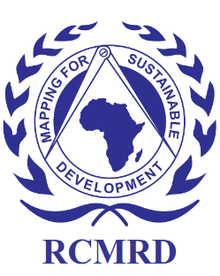 | Regional Centre for Mapping of Resources for Development (RCMRD)  Kasarani Road, Off Thika Road  P.O Box 632-00618  Nairobi, Kenya  Tel: +254 20 2680722/2680748  Cell :+254 723 786161/735 981098  Personal: +254 726 764 665  Fax:+254 20 2680747  Website:http://www.rcmrd.org, Email: kasera@rcmrd.org

