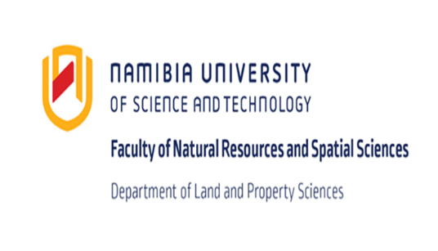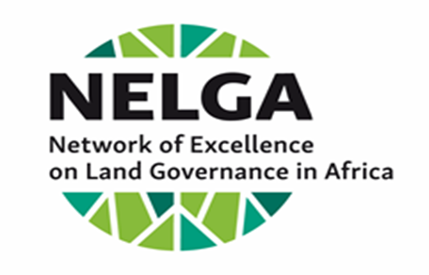

REGIONAL SYMPOSIUM ON LAND GOVERNANCE

THEME:

Policy implications and Land Governance Challenges in Southern Africa

3rd – 4th September 2019
NUST HOTEL SCHOOL
Windhoek, Namibia

Introduction

The Namibia University of Science and Technology (NUST) was selected as a regional node for the Network of Excellence on Land Governance in Africa (NELGA) for Southern Africa. The node was launched on 19 February 2018, although it was operational since June 2017. In its work plan, the node included collaborative research on land governance issues with regional partners. NUST as a Southern Africa Node along with selected NELGA partner institutions embarked upon a Regional Scoping Study on Land Governance in 2018. The study is being carried out with eight (8) country teams (Namibia, South Africa, Malawi, Botswana, Zambia, Zimbabwe and Eswatini) comprised of researchers from universities and research institutes from each participating country.

As a result, the Node is holding a 2-day Regional Symposium on the Land Governance Scoping Study. The symposium will include presentations of the country studies, a panel discussion and group work. The main objectives of the symposium is to identify regional land policy implications and key land governance challenges facing Southern African countries, and this will provide the basis for future research and improvements of land governance issues within the Southern African region. The symposium will also discuss the regional land policy implications and research opportunities to be compiled as a synthesis / executive summary.

Date

3-4 September 2019

Venue

The Symposium will be held at the NUST Hotel School, in Windhoek, Namibia

Key note speakers

- Dr. Rolf Becker (Dean: FNRSS)
- Prof Mutjinde Katjiua (HoD department of Land and Property Sciences: NUST)
- Mr. Klaus Bruckner (Director: GIZ-Namibia)
- Ms. Anita Hernig (Acting Team Leader- GIZ-SLGA)

Please note that attendance is strictly by invite

